STYLE GUIDE

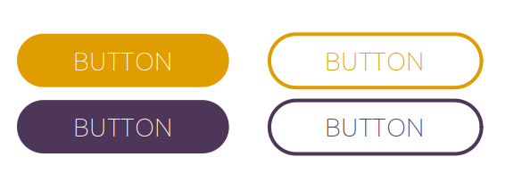    Header 1  Lorem ipsum dolor sit amet, consectetur adi piscing elit, sed do elusmod tempor incididunt ut labore and dolore magna aliqua.  This is an inline link.  Font: Ubuntu Thin / Color # | Dark Purple  #4d3658ff
Medium Purple
#7f6491

Light Purple
#cdc3d4ff

Orange
#e08000

Yellow
#e5da8fff

